MAWSON LAKES

SCHOOL OSHC

FAMILY HANDBOOK

Updated May 2024

# MAWSON LAKES SCHOOL OSHC

# MISSION STATEMENT

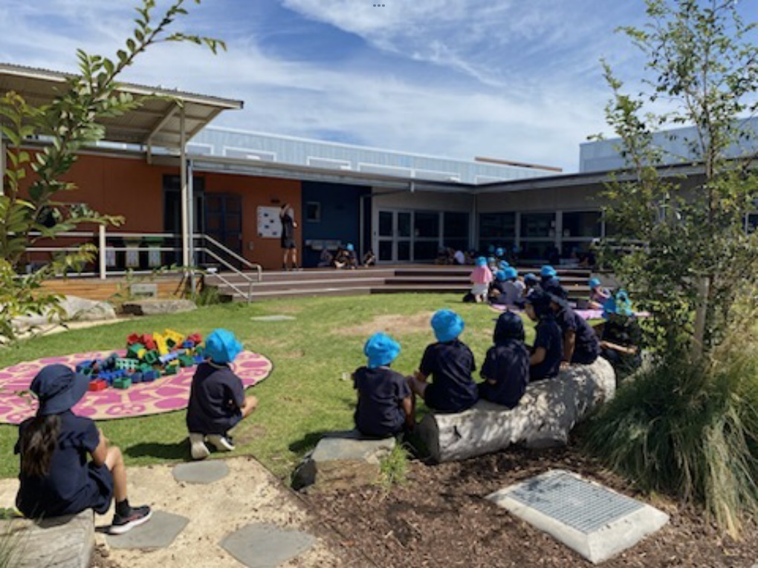“Our aim is to provide a safe, secure, play-based learning environment for all children. Through intentional teaching and critical reflection, our children will establish a sense of wellbeing while embracing all factors of a high-quality educational experience, which is inclusive and values diversity. This will be achieved through nurturing educators who will work in partnership with our families and our local community.”

OSHC

Reviewed - May 2024

# MAWSON LAKES SCHOOL OSHC

# MISSION STATEMENT

“Our aim is to provide a safe, secure, play-based learning environment for all children. Through intentional teaching and critical reflection, our children will establish a sense of wellbeing while embracing all factors of a high-quality educational experience, which is inclusive and values diversity. This will be achieved through nurturing educators who will work in partnership with our families and our local community.”

OSHC

**Welcome**

The staff and Governing Council of the Mawson Lakes School OSHC program would like to welcome you and your family to our OSHC service.   
We hope your child’s time with us is filled with many new and enjoyable experiences. All families are welcome to have a tour of our facilities and meet the OSHC staff. This can be arranged with the Director or Assistant Director at any time.

Please note: No smoking, dogs or alcohol permitted on school grounds.

The Mawson Lakes School OSHC program provides a warm, safe, secure educational and recreational environment for children and young people from Reception to Year 6. The staff is made up of caring and supportive educators who provide a stimulating, unbiased and positive environment.

**Educators**

Lorin Gillings - Director

Sue Sheridan - Assistant Director & Work Health & Safety Officer

Tatum Yarwood - Educational Leader & Medication Officer

All educators are trained in First Aid, CPR and have Responding to Risks of Harm, Abuse and Neglect - Education and Care training as well as Working with Children Checks.

**Hours**

Before School Care - 6:45am - 8:45am Monday to Friday

After School Care - 3:00pm - 6:00pm Monday to Friday

Vacation Care - 7:00am - 6:00pm Monday to Friday

Pupil Free Days - 7:00am - 6:00pm

SCHOOL CLOSURE - OSHC IS CLOSED

**Location**

OSHC is located on the site west campus

Postal - Yates Street, Mawson Lakes, S.A 5095

After School Care - 0401 121 318

**OSHC Management Committee**

Mawson Lakes School OSHC has a sub-committee of the Governing Council which represents us and makes recommendations on behalf of OSHC to our school Governing Council. The OSHC Management Committee comprises of parents, OSHC educators and leadership of Mawson Lakes School.

**Priority of Access**

The Mawson Lakes School OSHC program follows the Commonwealth Government’s Priority of Access Guidelines for children using the service. These guidelines may be accessed in the OSHC Priority of Access Policy.

**Inclusion Policy**

Mawson Lakes School OSHC supports and encourages children with additional needs into our service. We are committed to providing an environment for all children and young people celebrating all abilities. We understand each child’s learning and development outcomes in relation to their identity, ability, and connections with the community.

**Fees**

Before School Care $18 per day - includes breakfast

After School Care $23 per day - includes afternoon tea

Vacation Care $60 per day - includes afternoon tea

Pupil Free Days $60 per day - includes afternoon tea

Early finish @2pm - $25 - includes afternoon tea

The OSHC service reserves the right to refuse a child access to the service based on outstanding accounts. Families need to take full responsibility for payment of all OSHC debts.

A late collection fee of $5 for the first five minutes. After 6:05pm, $20 will be charged to your account for every fifteen minutes after. If a child has not been picked up by 6:30pm and all attempts to contact parents, guardians, emergency contacts have been exhausted, Crisis Care and the police will be contacted.

**Enrolment & Registration**

An enrolment form is required for each child and is available from the front office, OSHC, Skoolbag or school website. This must be completed and returned before the child attends the service. Please advise the Director of any changes to the information on the enrolment form.

**Child Care Subsidy (CCS)**

If you are eligible for Child Care Subsidy you must make sure you have lodged all your details with Centrelink and keep your information up to date in your myGov account.

**Bookings & Cancellations**

Phone- 0401 121 318 or email: MawsonLakes.OSHC@schools.sa.edu.au in writing or in person.

Seven days’ notice is required for cancellation of all booked care. Families who do not notify the service of cancellations will be charged full fees.

If a child is sick, full fees (including CCS), will still be charged. If by the third day the child is still sick, the booking will be cancelled. The school does not let us know if your child is absent or has left the school early, so it is your responsibility to notify us.

**Vacation Care** - Cancellations are not accepted after the booking due date. Families will be charged for all days booked and sick certificates will not be accepted.   
**Exceptions** - In the case of a medical emergency or family issue, please discuss with the Director.

**Photographs**

Our service takes photos daily of the children and young people doing various activities and experiences. Please notify our educators if you do not wish your child’s photograph to be taken or placed on display, or on the school website.

**Incidents, Accidents, & Illness**

If a child is injured at the service first aid will be administered by a qualified educator.

An incident form will be filled out and shown to the parent, who then needs to sign the form.

If the injury is of a serious nature, we will call the parent/s and an ambulance.

If a child becomes ill at the service, educators will make the child as comfortable as possible until they are picked up. If the educator warrants that the child’s illness is serious enough to be sent home, a phone call will be made to parents or emergency contact to come and collect them straight away. Depending on the illness the child may need to be isolated.

**Medication**

Medication can only be given to a child if it is a prescribed medication accompanied by a letter from a medical practitioner. It must state the time it is to be administered, and in its original packaging with a pharmacist’s label which clearly states the child’s name and dosage.

Parents will be asked to supply an Action Plan and sign a Health Support Agreement and fill out the service’s Medical Agreement form, if a child takes requires medication.  
 When a child requires their prescribed medication, two qualified educators will supervise the administering of the medication. They will then both fill out and sign the medication log with the date, time, and dosage.

**SunSmart Policy**

Mawson Lakes School OSHC is a registered SunSmart service which is endorsed by the Cancer Council SA. We actively encourage all children to wear bucket hats and apply sunscreen 20 minutes before going outdoors when the U.V is forecast at 3 and above. Children are not allowed to wear sleeveless shirts or thongs during the hotter months for safety sun-safe reasons.



**Check-In and Departures**

Children and young people from site west are responsible for walking to OSHC from their class once the bell has gone. An OSHC educator will sign the child/ren in under the veranda at TR12. At 2:55pm five educators walk to site east to collect the junior primary children. One educator goes to each building to collect all children and young people that are attending OSHC on the day. Once all children and young people are accounted for the educators will safely make their way back to OSHC on site west.

For further details please see our Delivery and Collection routine.  
   
Any students still on the school grounds after 3:15pm will be brought to OSHC by the teacher on yard duty. We will notify parents to come and collect them.  
Children must be collected by a parent or a nominated person before 6:00pm.

Parents need to sign their child in and out daily.

**Breakfast & Afternoon Tea**

The program provides breakfast for all children and young people before 8am. Afternoon tea consists of a snack upon arrival. If your child has dietary requirements, please specify on the enrolment form.

The service takes into consideration religious and dietary requirements for all children.

On Pupil Free Days and in Vacation Care children and young people are required to bring recess, lunch, and a water bottle. Breakfast and afternoon tea will be provided by OSHC.

Please remember we have children and young people in our care who have life-threatening NUT ALLERGIES.

NO NUTS OR PRODUCTS THAT CONTAIN NUTS ARE ALLOWED AT OSHC.

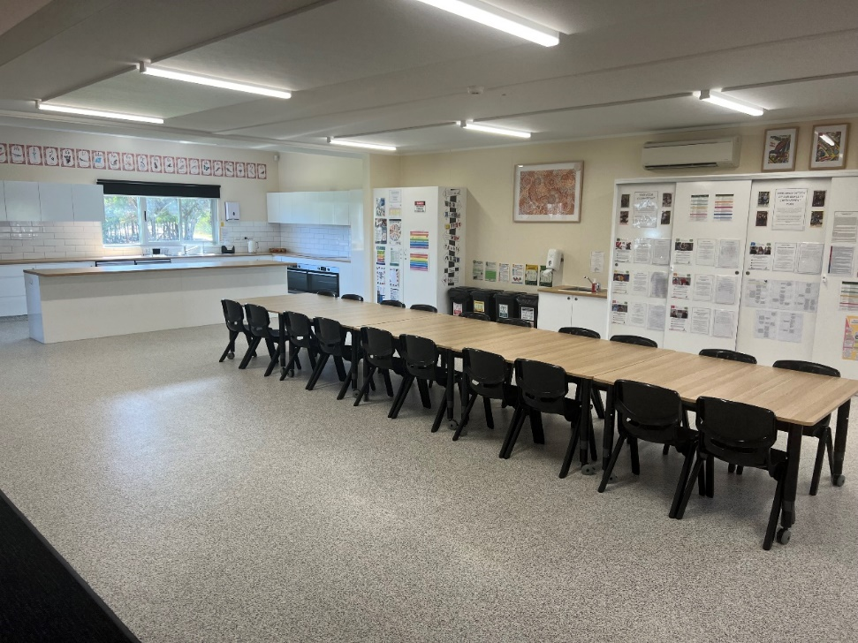

**Behaviour Management**

All children and young people are required to follow the school and OSHC values.

The Mawson Lakes School OSHC encourages children and young people to problem solve. If there is a problem the educator will ask the children involved with the incident to sit together and discuss the problem and come to a compromise. The educator will not resolve the problem, but rather mediate and encourage the children to try to work it out for themselves.

Everyone has the right to feel safe in our environment therefore any child deliberately physically hurting or continuously bullying other children and educators will not be tolerated.  
   
Parents will be called to come and collect their child immediately and the incident will be   
documented. A policy is in place for children who continuously do not follow OSHC rules. A “inappropriate behaviour form” will document the incident and parents will need to sign the form and then return it to OSHC.

A procedure for re-inclusion to care will be worked out between the OSHC Director and parents or guardians.

**Vacation Care Transportation**

All excursion transportation will be done by a private coach line with seat belts. Parents will be asked to sign their consent through their Vacation Care booking form.

Excursion activities are flexible, and the program is subject to change-weather permitting or COVID protocol.

**Suggestions, Feedback & Grievances**

Mawson Lakes School OSHC invites suggestions or ongoing feedback from children, families and OSHC Educators and treats all communication in a professional and confidential manner. Please feel free to talk to the OSHC educators regarding any feedback or grievances about the service. A convenient time can be made to speak one on one with the Director if required. Other means of communication include email, texts, the use of the suggestion box, or the Parent Comment and Contribution form.  
It is the responsibility of the parents or guardians to notify the OSHC Director of any relevant or important information relating to the care, collection, or supervision of their children.

**Programming**

The role of programming at the service is to influence, inspire, motivate, affirm, challenge, and extend the children and young people of the service. The formulation of our monthly program incorporates multiple activities to achieve a diverse range of learning outcomes for individual children. This practice reflects the multi-cultural and social nature of the community, based upon the National Quality Standards and My Time, Our Place Learning Framework. Our OSHC programming foundation consists of Kid’s Club, Parent Comment and Contributions, Program Extension, and Intentional Teaching.

Kid’s Club

Allows the children to put forward their ideas, interests and wants which are incorporated into our programming and vacation care calendar.

Parent Comment and Contributions

Gives our families the opportunity to contribute to the planning and programming of the service by putting forward their ideas and giving feedback.

Intentional Teaching

Is an outlet for educators to embrace and build on a child, or children’s strengths in a targeted area.

Program Extension

Is made up of activities from Kid’s Club and Parent Comments and Contributions which we believe as a service a child or children’s needs were not met.

